Music is a moral law. It gives soul to the universe, wings to the mind, flight to the imagination, and charm and gaiety to life and to everything.
~ Plato
- Greeting One Another
- Sounding the Tibetan Bowl
- Call to Community
Community Means Strength
by Starhawk*
- Candles of Community
- Prelude
- Lighting the Chalice
Candles and Concerts
by Dan Althoff*
- Spoken Affirmation
Love is the spirit of this church … and service is its law.
This is our great covenant … to dwell together in peace,
To seek the truth in freedom … and to help one another.

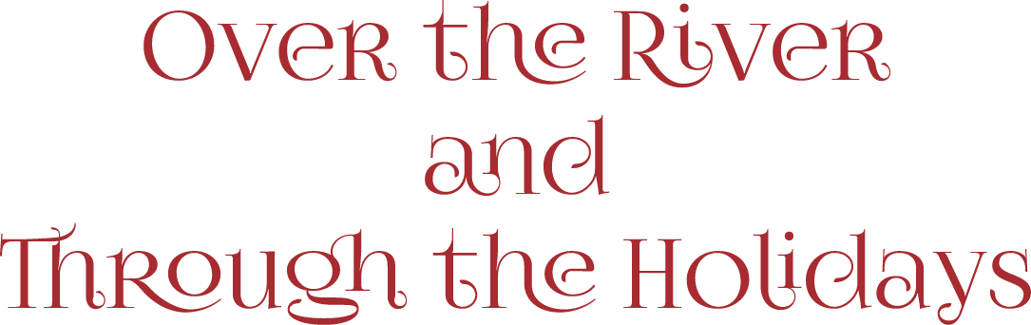

Over the River and Through the Wood
O Come, O Come Emmanuel
Light One Candle
Jolly Old St. Nicholas
The Bodhi Tree
Sing of Mary, Pure and Lowly
O Christmas Tree
*Lifting up contributions from Unitarian Universalists
Here We Come A-Wassailing
God Rest Ye Merry Gentlemen
O Come, All Ye Faithful
It Came Upon the Midnight Clear*
Joy to the World
Have Yourself a Merry Little Christmas
Good King Wenceslas
Kwanzaa Celebration
Oshogatsu
Auld Lang Syne
- Giving
Those who wish may bring their gifts to the table or give on the church mobile app home screen
- Parting Thought
As We Listen to the Blessing of Music
by Maureen Killoran* (adapted)
- Extinguishing the Chalice
We extinguish this flame but not the light of truth,
The warmth of community or the fire of commitment.
These we carry in our hearts until we are together again.
- Postlude

Program Notes
Leading today’s morning assembly is the Worship Team who thought a morning of seasonal music, some familiar, some you’ll hear for the first time is a perfect way to kick off this, The Season of the Heart.
The Committee on Ministry always meets after the morning assembly on the fourth Sunday of each month. If you wish to speak with the committee, please reach out to either Carolyn Cameron or Elbert Hill. Conversations with the Committee on Ministry are always confidential.
The Newsletter Deadline was yesterday. If you missed it, please take time this afternoon and send your submission to news@redriveruu.org.
Did you know that the wednesdayUPDATE is now also available on the church website? (It has always been on the church mobile app by tapping the UPDATE tab on the home screen.) A handy reference if you accidently deleted it from your email inbox. You will find it on the Events list, located on the homepage. The UPDATE is emailed each Wednesday and if you are not receiving it and would like to, email your request to news@redriveruu.org.
Making Things Happen Today
- Today’s Board Rep: David Dyer
- Greeting us at the door: Carol Powell
- Host: Marion Hill
- Leading Things: The Worship Team: Dan, Doug, Marla
- Musicians: Dan Althoff, Jan Fletcher, Marla Loturco
- AV Crew: Carole Harner, Don Rogers, Jim Holmes
- Sunday School Leader: Ellie Dyer

Continued on back panel

Welcome Guests
W
e are Unitarian Universalists. We are brave, curious, and compassionate thinkers and doers. We are people from many backgrounds who have different beliefs, but shared values.
Grounded in more than two hundred years of thoughtful, spiritual communities, we are people of many generations, ethnicities, genders and sexualities, and spiritual backgrounds. People engaged in making the world a better place. People focusing on what really matters – love, justice, integrity, and hope.
We are a lay-led congregation. Lay-led congregations have no minister which means members of the congregation manage the various aspects of our church life. Unitarian Universalism has a proud tradition of lay-led churches.
We Unitarian Universalists have different beliefs, but shared values. We are Unitarian Universalists, and at the same time we may also be agnostic, Buddhist, Christian, Hindu, humanist, Jewish, Muslim, pagan, atheist, believers in God, and those who just let the great mystery be. The diversity of beliefs you’ll find in our church community is one of our strengths – we’re always learning how to see the world from a different perspective.
Learn more about us at your leisure by downloading our app ‘Red River UU’ from Google Play or the Apps Store.
This is who we are.
We are glad you came today.

Next Sunday, December 5, 2021
10 am - Adult Forum
11:15 am - The Morning Assembly
Justice as Equality of Opportunity
The Rev Dr Mark Y.A. Davies, leading
Reflections on John Rawls' veil of ignorance thought experiment that led him to develop the theory of justice as equal opportunity. How would the adherence to a view of justice as equal opportunity change the way we think about our systems of economics, politics, education, healthcare, and more?

12:15 pm - Coffee and Conversations - Suspended for now due to the Delta Variant.

Red River Unitarian Universalists
515 North Burnett Ave
mail: PO BOX 1806
Denison, TX 75020
903.231.3232  www.redriveruu.org

TO OUR VIRTUAL FRIENDS: We live stream our Sunday
Activities on our Zoom Account: Meeting ID: 989 0789 7878

Our Mobile App: ‘Red River UU’ free from Google Play, and and the Apps Store or scan the QR code >>>>

The Morning Program
Sunday, November 28, 2021

To Dwell Together in Peace

